**Name : Animesh Kashid**

**Roll No : 19102A0073**

**Branch/Div: CMPN/A**

**Subject: Audit Course Level 1 Task**

**Project Name: Gaming Desktop Wallpapers**

|  |  |
| --- | --- |
| Front End Tools | HTML 5, CSS3 |
| Project Leader | Animesh Kashid |
| Project Language | English |
| Country | India |
| Reference sites | www.w3schools.com |
| GitHub Repository Link | https://github.com/animeshVIT/Audit-Task-1-Animesh-Kashid |

**Project Description:** The Gaming Desktop Wallpapers is a small website. The whole intension of this project is being able to create a responsive website which has a feature with which you can download wallpapers available on the website. This is a part of an Audit Course named “Industry Ready Web Developer” in which I have used Basic HTML and CSS to create a raw layout of the website and further improvisations are needed to make it more dynamic and ready to use which will be done as we approach further levels. Below attached are the screenshots of the work done till now.

**Screenshots:**

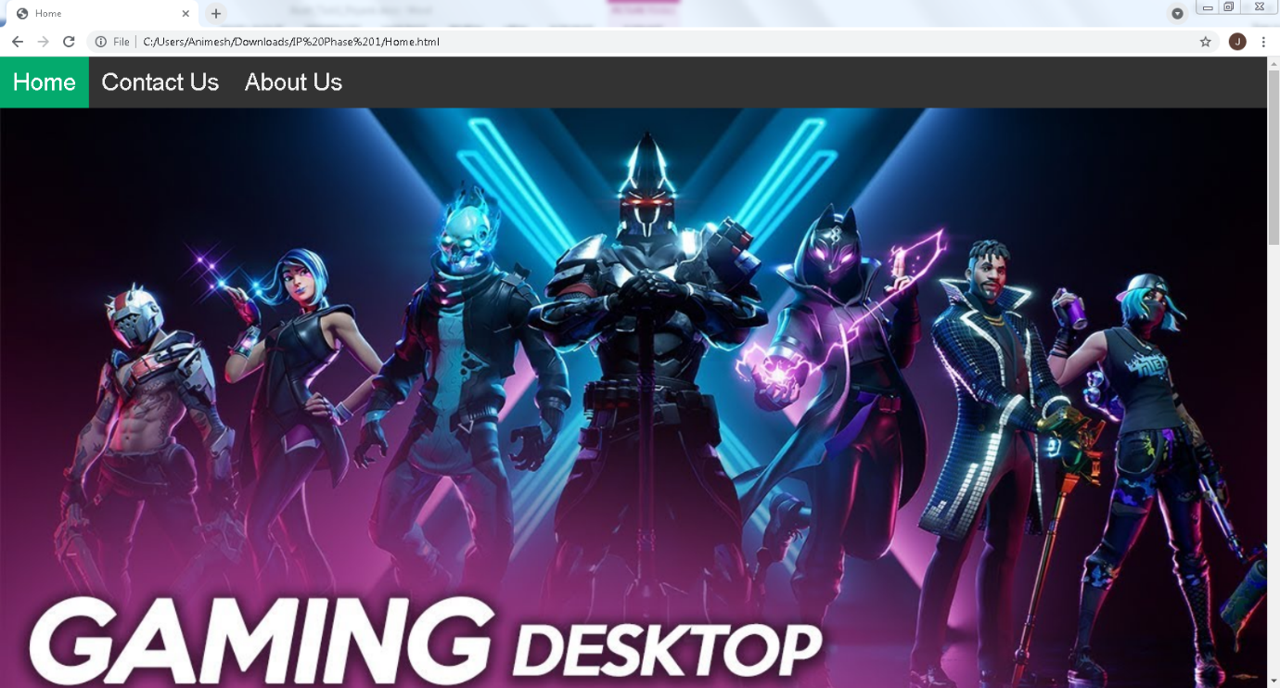

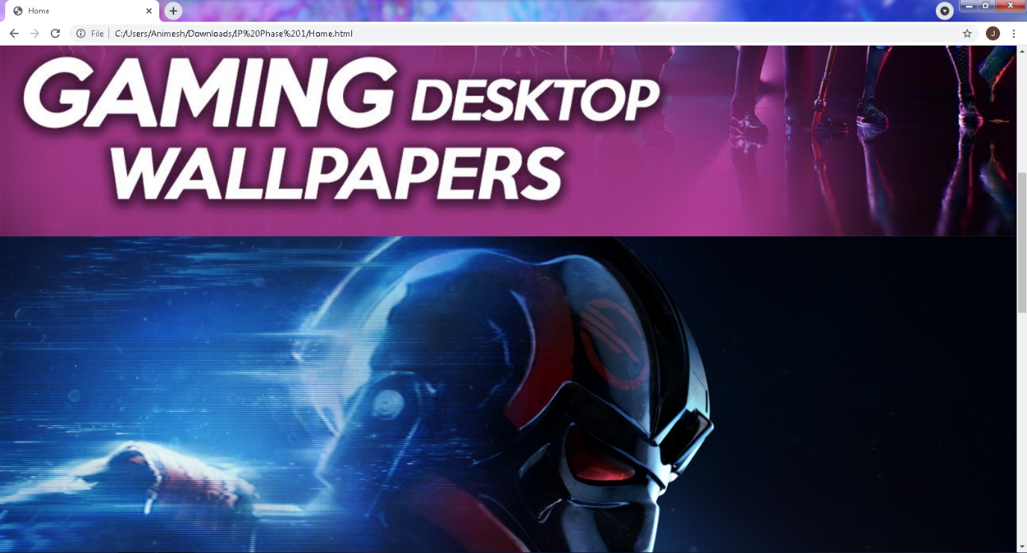

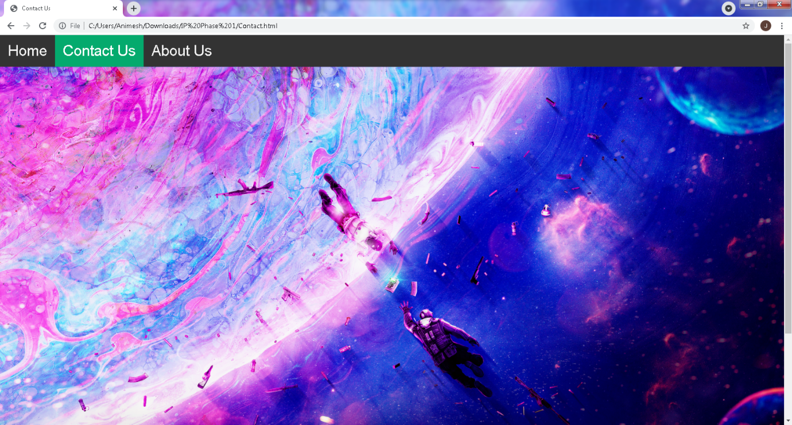

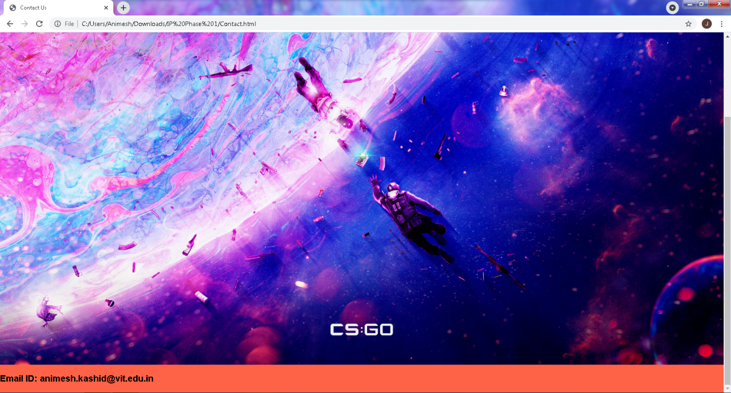

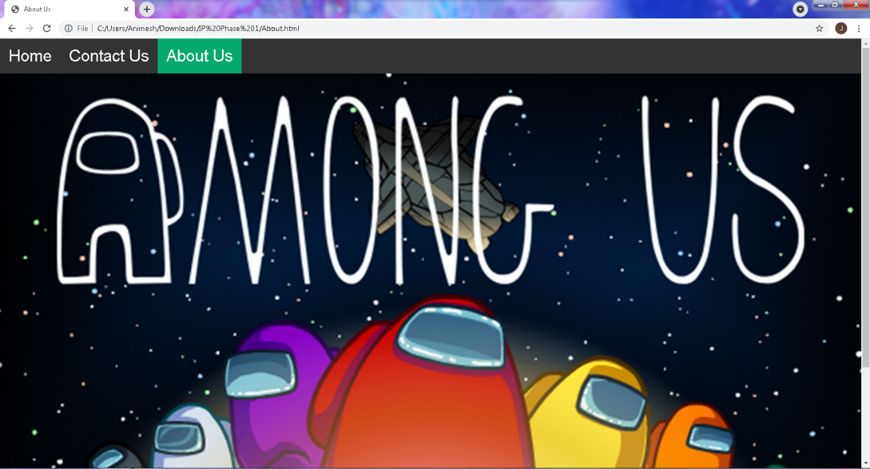

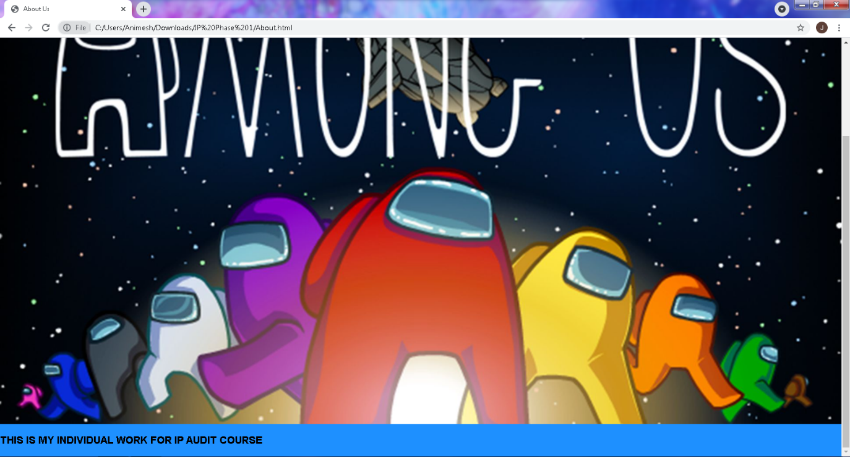

**Repository Link Here: https://github.com/animeshVIT/Audit-Task-1-Animesh-Kashid**